

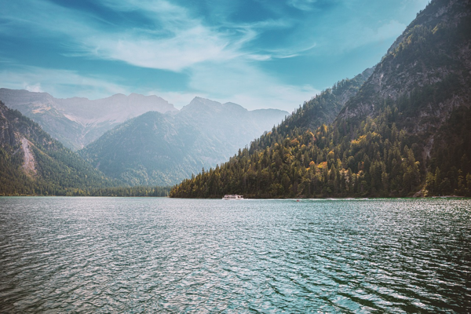

**Day 11: Farewell to Jammu's Splendor**

Travel: Local sightseeing in Jammu   
After breakfast, visit Raghunath Temple and Ranbireshwar Temple, exploring the spiritual heritage. Afternoon visit to Mansar Lake for a scenic walk. In the evening, reflect on our trip at a farewell dinner, fondly expressing gratitude for our experiences together.  
  
---